Harmanjot Singh
Profess Travis Faas
Tic-Tac-Toe
27 October 2020
Project 1 Report

Class Diagram -

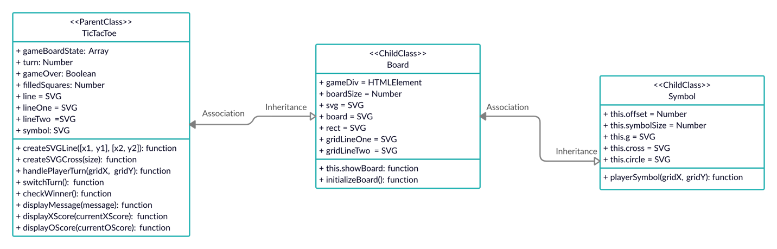

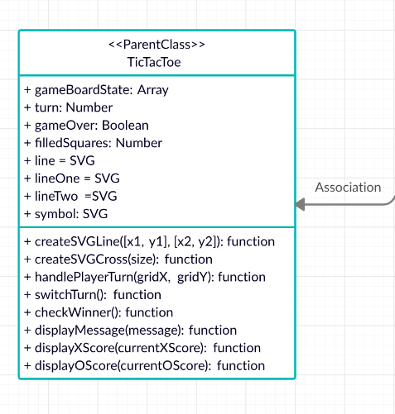

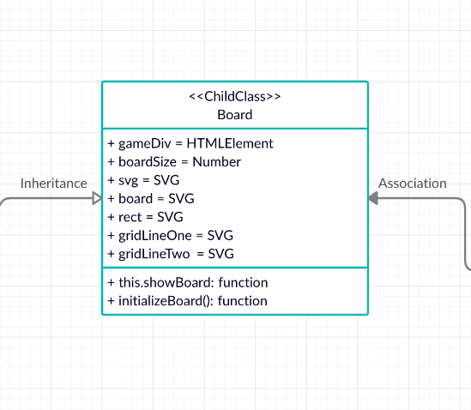

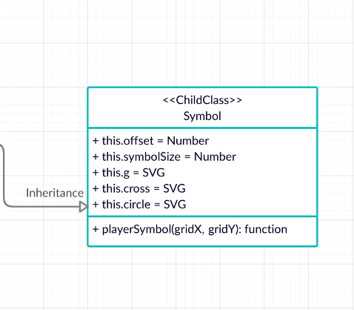
Wireframe -
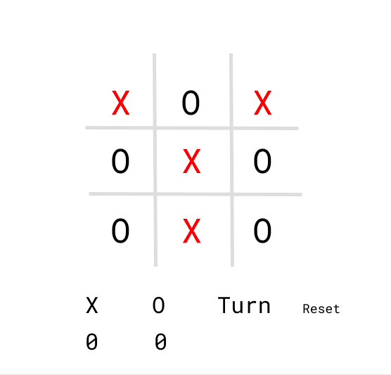

Flow Chart -
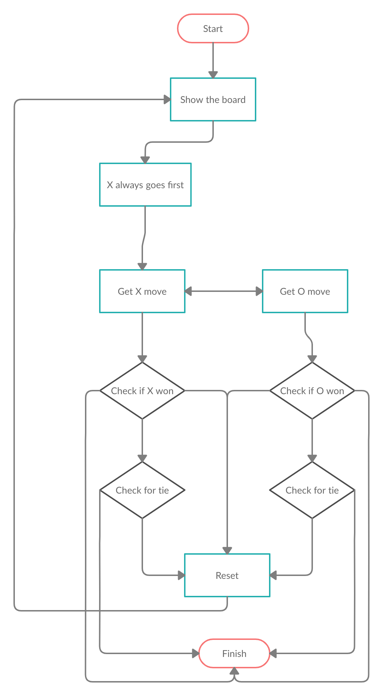

May be explain the code here as well with screenshots

